Abstract template for the March 2026 S3C
[Title: Times New Roman, 16p, Bold, centered]

[1 blank line after the title. Remove all text in red]
First Author¹, Second Author², and Presenting Author^{1,2}
[Name: Times New Roman, 12p, centered, underline presenting author]
¹School of Molecular Sciences, Arizona State University, Tempe, AZ 85287 United States
²ETH Zurich, Department of Chemistry and Applied Biosciences, Zurich, Switzerland
[Affiliation; Times New Roman,10.5p, centered]
[1 blank line after affiliation]
Your Abstract text goes here. Figures are optional. The objective of the S³C meeting is to provide a forum for scientists working in the field of small clusters and nanoparticles. It provides an informal atmosphere to facilitate discussions, idea generation, and networking [1,2]. [Font: Times New Roman, 10.5p]

Please do not change the page size, margins and spacing.

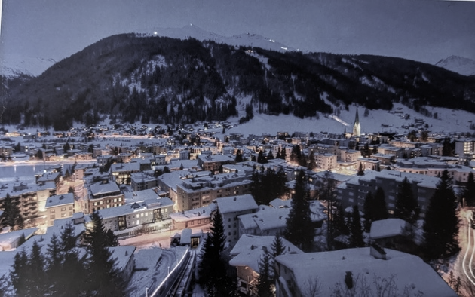

Fig.1 Davos. [9p]

References [10.5p]
[1] J.M. Garcia, L.F. Heald, R.E. Shaffer, S.G. Sayres, “Oscillation in Excited State Lifetimes with Size of Sub-Nanometer Neutral (TiO₂)_{n} Clusters Observed with Ultrafast Pump-Probe Spectroscopy”, J.Phys.Chem.Lett., 12, 4098-4103 (2021). [9p]
[2] H. W. Kroto, J. R. Heath, S. C. O'Brien, R. F. Curl, and R. E. Smalley, “C₆₀: Buckminsterfullerene,” Nature 318, 162 (1985).

